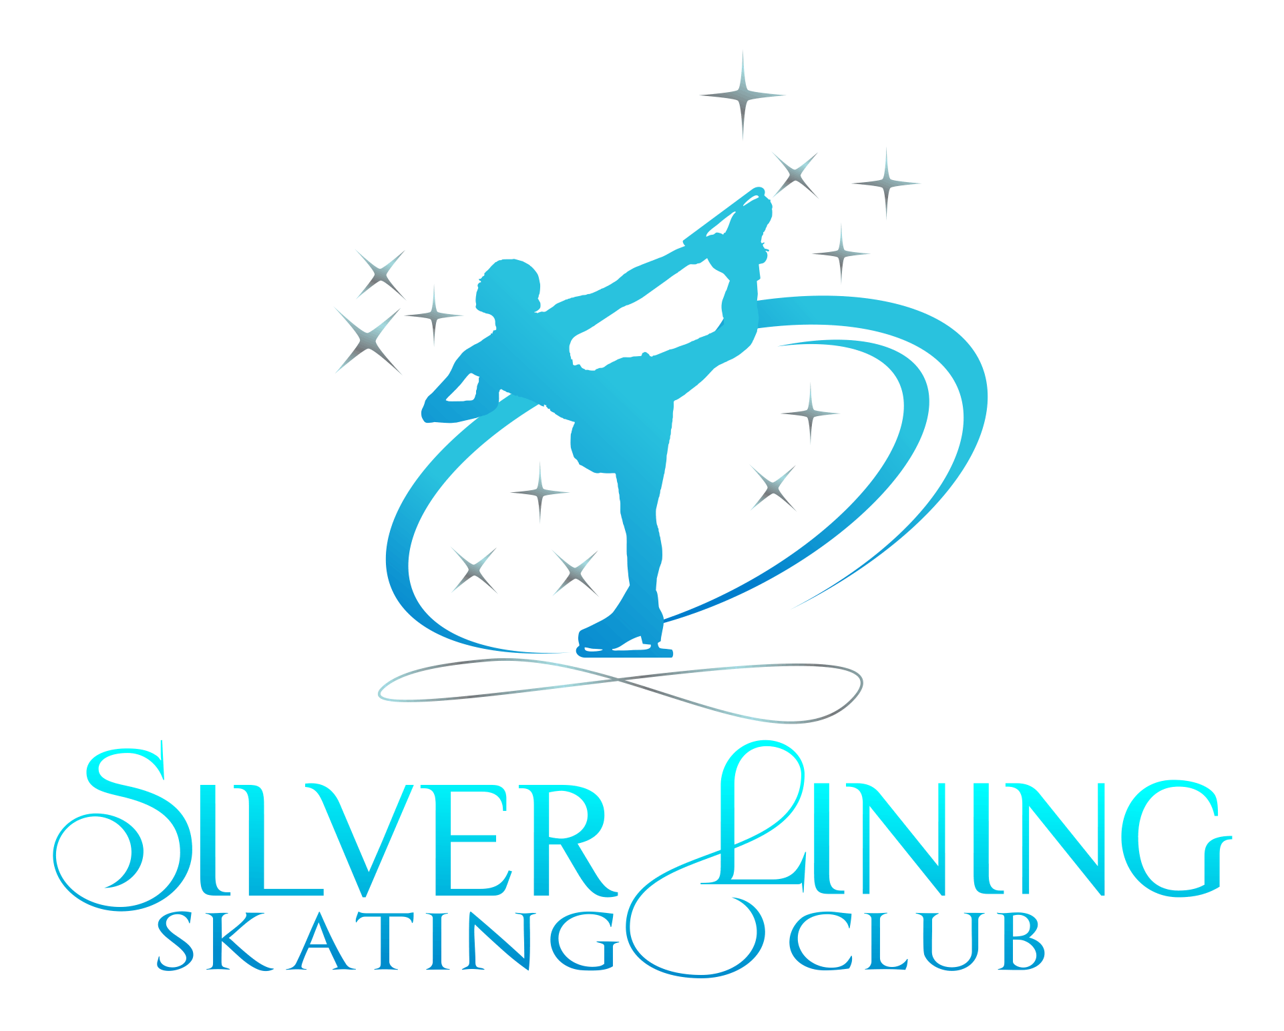
Parental/Guardian Consent for Medical Attention or Treatment & Liability Waiver
2020-2021
In consideration of participating in club activities, I represent that I understand the nature of figure skating activities and that I am qualified, in good health and in proper physical condition to participate in figure skating. I acknowledge that if I believe event conditions are unsafe, I will immediately discontinue participation. I fully understand that this activity involves risks of serious bodily injury, including permanent disability, paralysis and death, which may be caused by my own actions, or inactions, those of others participating in figure skating, the conditions in which figure skating takes place, or the negligence of the “releasees” named below; and that there may be other risks either not known to me or not readily foresee- able at this time; and I fully accept and assume all such risks and all responsibility for losses, costs, and damages I incur as a result of my participation in figure skating.
I hereby release, discharge, and covenant not to sue the club, ISI, it’s directors, officers, administrators, sponsors, volunteers, agents, employees, staff, instructors, trainers, other participants and if applicable, owners and lessors of premises on which figure skating takes place from all liability, claims, demands, losses, or damages on my account caused or alleged to be caused in whole or in part by the negligence of the “releasees” or otherwise, including negligent rescue operations; and I further agree that if, despite this release, wavier of liability, and assumption of risk, I, or anyone on my behalf, makes a claim against any of the releasees, I will indemnify, save and hold harmless each of the releasees from any loss, liability, damage or cost which any may incur as the result of such claim. As the minor’s parent and/or legal guardian, understand the nature of the above referenced activities and the minor’s experience and capabilities and believe the minor to be qualified to participate in figure skating. I hereby release, discharge, covenant not to sue and AGREE TO INDEMNIFY AND SAVE AND HOLD HARMLESS each of the Releasees from all liability, claims, demands, losses, or damages on the minor’s account caused or alleged to have been caused in whole or in part by the negligence of the Releasees or otherwise, including negligent rescue operations, and further agree that if, despite this release, the minor, or anyone on the minor’s behalf makes a claim against any of the above Releases.
I WILL INDEMNIFY, SAVE AND HOLD HARMLESS each of the Releasees from any litigation expenses, attorney fees, loss liability, damage, or cost any Releasees may incur as the result of any such claim.
I certify that as the parent/guardian of said participant, give my consent to the club and the facility the activities are taking place in and their staff and to members of the club, Board of Directors, and volunteers to obtain medical care from any licensed physician, hospital or clinic, including transportation and emergency medical services, for myself/ourselves and/or said participant for any injury that could arise from participation in these activities. This consent for Medical Attention shall be binding and effective for the current membership year 2020-2021.
Name of Skater: ____________________________________Allergies/Conditions:______________________________
Print Name of Parent/Guardian:______________________________________________________________________
Signature of Parent/Guardian:________________________________________________________________________
Emergency Contact Person: ________________________________________Phone #:___________________________
Preferred Hospital:____________________________________ Insurance Policy Holder:__________________________

