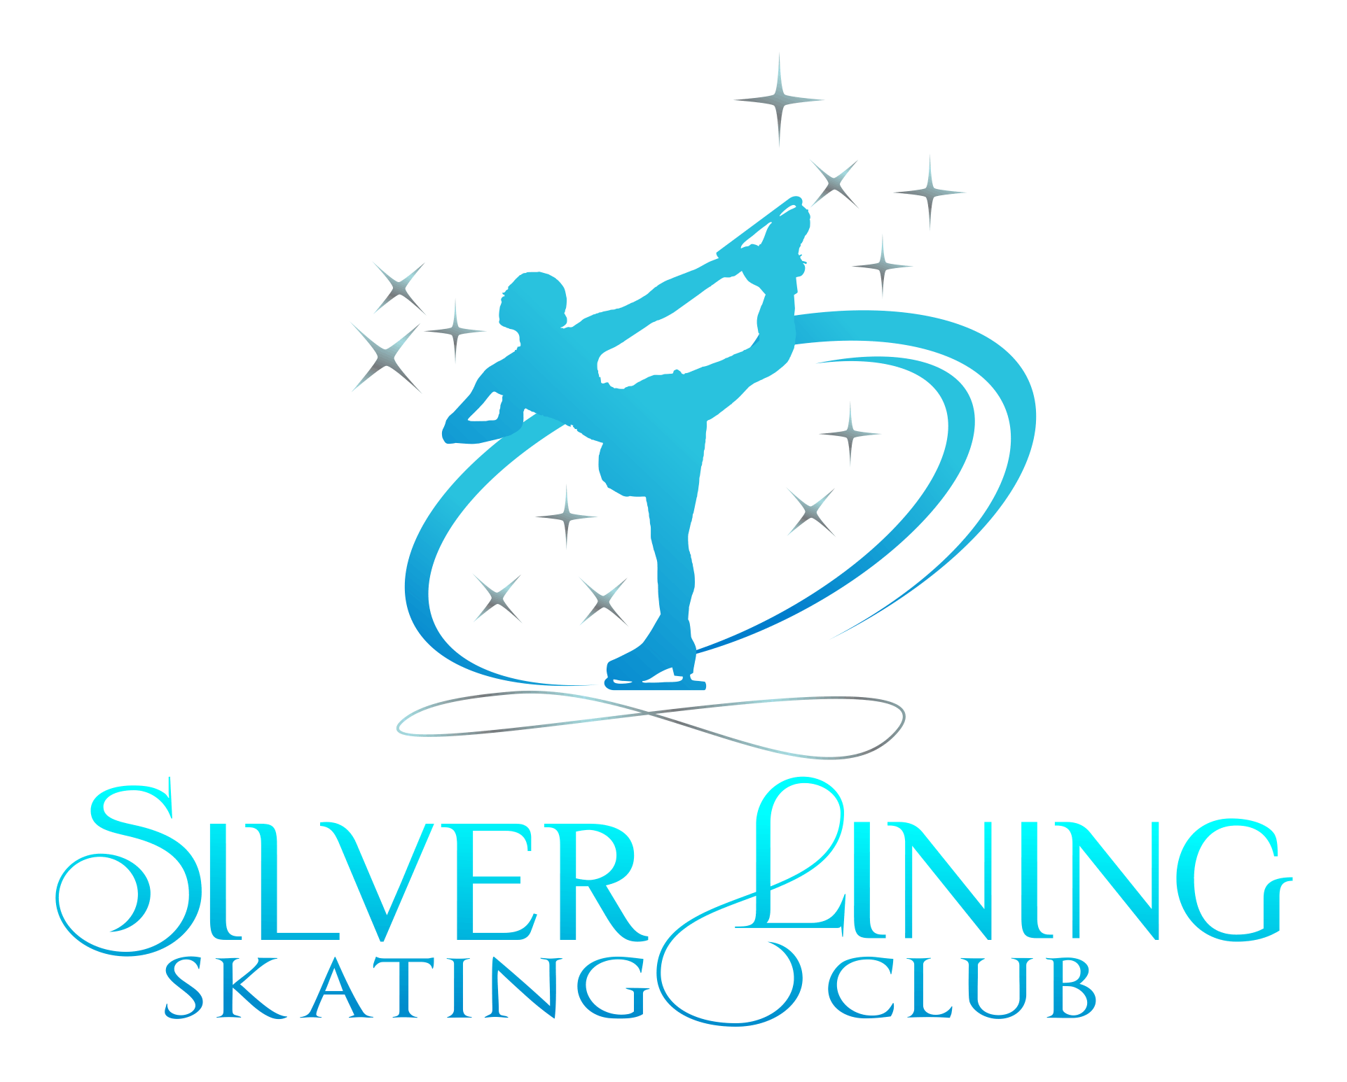

2020-2021

Parent/Guardian Code of Conduct

This Parent/Guardian Code of Conduct gives a guide to what is expected of all parents and guardians, as we are all part of a club, participating in a sport, and spectators of the skaters activities and events. We are here to be supportive and make this a safe and positive environment for all those participating.

As Parent/Guardian, to the best of my ability through both my actions and words I will;
- Encourage good sportsmanship by demonstrating positive support for all skaters, coaches and officials at every practice session, competition and test session.
- Place the emotional and physical well being of my child ahead of the desire to win.
- Encourage my child to skate in a safe and healthy environment.
- Inform my child’s coach of any physical disability or ailment that may affect the safety of my child or the safety of others.
- Teach my child that doing one’s best is more important than winning, so that my child will never feel defeated by the results of a competitive event.
- Never ridicule or yell at my child or other participant for making a mistake or blame my child’s teammates for placement in a competition.
- Do my best to make skating fun and will remember that my child participates in sports for his/her own enjoyment and satisfaction, not mine.
- Ask my child to treat other skaters, coaches, fans, and officials with respect regardless of race, creed, color, sexual orientation or ability.
- Applaud a good effort in both victory and defeat emphasizing the positive accomplishments and learning from the mistakes.
- Teach my child to resolve conflicts without resorting to hostility or violence.
- Be a positive role model for my child and other skaters.
- Demand a figure skating environment for my child that is free of drug or alcohol abuse and agree that I will never use or provide any drug proscribed by applicable federal, state, or municipal law.
- Not assist or condone any athlete’s use of a drug banned by the International Olympic Committee, International Skating Union, United States Olympic Committee, or US Figure Skating, or use of drugs of any kind, or form, both on and off the ice.
- Not provide alcohol to, or condone the use of alcohol to minors, abuse alcohol in the presence of athlete members, or at skating activities or, in the case of athletes, consume alcoholic beverages while a minor.
- Encourage my child’s coach to continue their education and training through programs offered by all accredited figure skating organizations.
- Respect my child’s coach and refrain from coaching my child or other skaters during competitions and practices because it may conflict with the coach’s plan or strategies, as they are the professionals and I am not.
- Respect the decisions of coaches and officials during competitions and test sessions.
- Show appreciation and recognize the importance of volunteering whenever possible, to aide in providing a safe skating environment and successful events.
- Know the rules and regulations of Safe Sport, and follow guidelines for reporting misconduct and abuse of any kind.
- Support all the opponents in my child’s competition and respect the rights of all skaters to participate.
- Direct questions or concerns regarding the decisions made by officials to a member of our coaching staff. Parents address officials via the coaching staff only.
- Address and fully review Skaters Code of Conduct with my child, and be sure they are aware of their roles as skaters of Silver Lining Skating Club and the rules for participating in any Club activities and using freestyle ice.
- Conduct myself in such a way that brings discredit or discord to the club, or national governing body, I will voluntarily subject myself to disciplinary action. The club maintains the right to terminate any membership with/without cause in the interest of our vision, mission and objectives.

I have fully read and understand all of the above statements, and agree to conduct myself in a manner that demonstrates the standards listed above on the Parent/Guardian Code of Conduct.

Skaters Name:___________________________________________________
Parent/Guardian Name:_____________________________________________
Parent/Guardian Signature:___________________________________________Date:___________________

